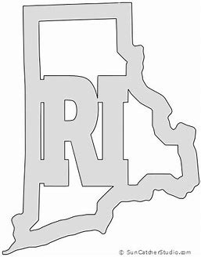
Rhode Island Open
BOWLING CHAMPIONSHIPS

September 18-19th, 2021
Registration 9:00-9:50am bowling at 10
Location: East Providence Lanes
$85 Entry (60PF, 20lin, 5exp)

REGISTRATION FORM
Name:________________________________________________________________________________________

Home Center:__________________________________________________________________________________

Phone/Contact info:_____________________________________________________________________________

Format:
Day 1: 6 games of qualifying across 12 lanes with the top 8 scores advancing with pins carrying over.
Day 2: 8 games of round robin match play with bonus pins including a position round in game 8. Cut to the top 4 for stepladder final (Fresh Pair).
Scratch bowling event open to bowlers in all surrounding areas!
Details:
Tournament will be conducted on 2019 USBC Open Championships condition.
There will be side pots and bonus events available both days, with Squad Leader, High Game including in entry. Min 1 in 8 Cash.
Tournament Director will be Jeff Handy.

- High Game and Squad Leader pots will be included in entry, brackets and other sides will be available. RI Masters entry will be paid from proceeds of sponsors and raffles.
- The lane pattern will be the 2019 USBC Team Pattern for both days.

Prize fund based on 60 entries (field limited to 75 bowlers) [60pf – 5 for HG/SqLD = 55 * 60]
Plus $25 HG each game and $120 Squad leader

